Bulk Completion of Sub-Tasks
Select the Sub-Tasks as normal in Issue Navigator
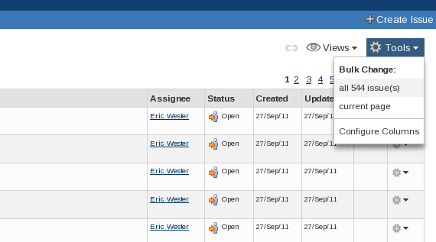
Select the Tools drop-down menu, situated on the right above the list of issues.
From the Bulk Change section of the menu select either 'all 9999 issue(s)' or 'current page'

Step 1
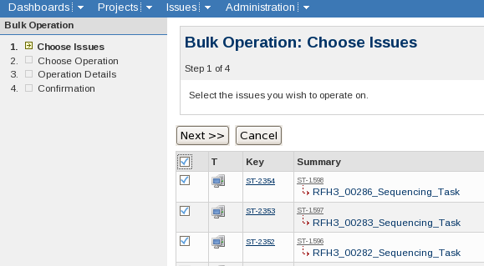
Use the tick-box in the header section of the table to select all of the sub-tasks.
Click Next>>

Step 2
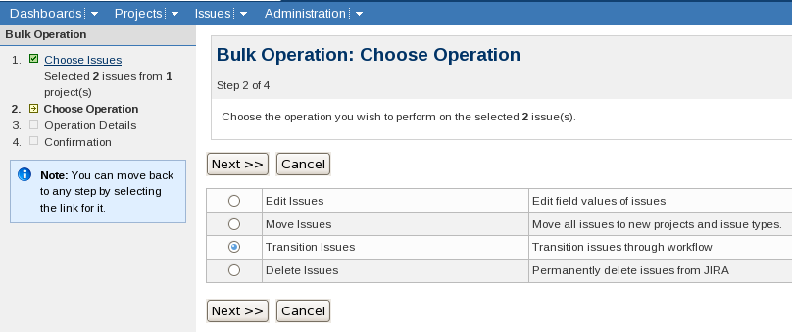
Select Transition Issues
Click Next >>

Step 3a
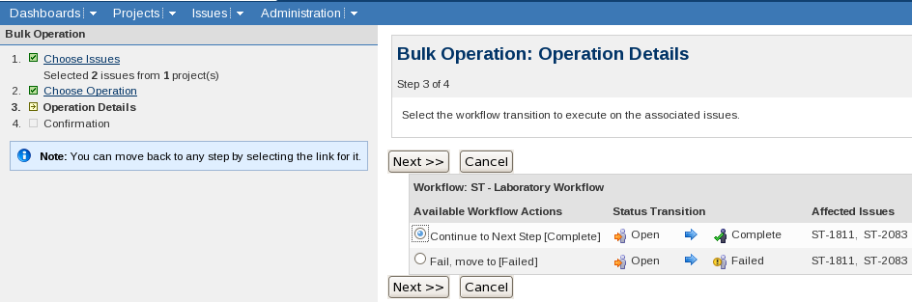
Select Continue to Next Step [Complete]
click Next>>

Step 3b
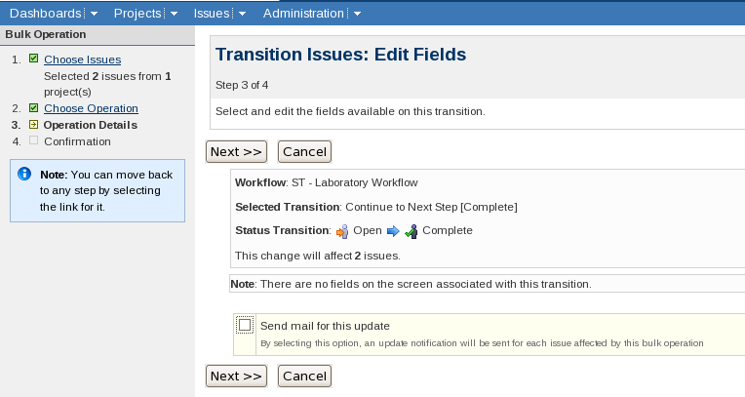
Deselect the check-box next to 'Send mail for this update' (if necessary)
Click Next >>

Step 4
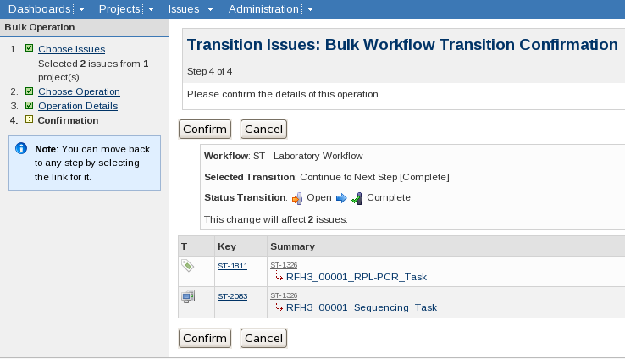
Click Confirm

Viewing only open sub-tasks
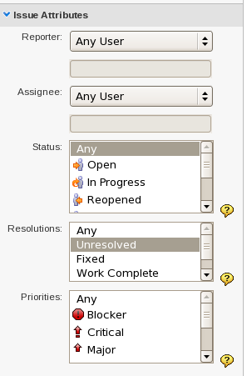
To hide the sub-tasks that have been completed make sure that the search has Resolutions: set to Unresolved.

Completing a Sub-Task from the Parent Sample's Page
Near to the bottom of a Samples summary page is a block of Sub-Tasks (If the Sample has no Sub-Tasks then this block isn't shown).
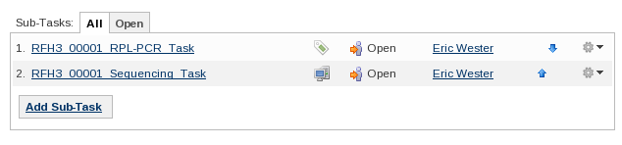
Each Sub-Task is on a separate line. At the right hand side of the line is a cog symbol with an arrow pointing down:
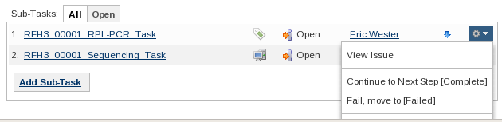
Clicking on the symbol brings up a menu. The second section contains the 'transitions' available for the Sub-Task. Clicking 'Continue to Next Step [Complete]' will transition the task to Complete.

Setting which fields are displayed when searching
This also sets which fields are shown when performing a bulk operation
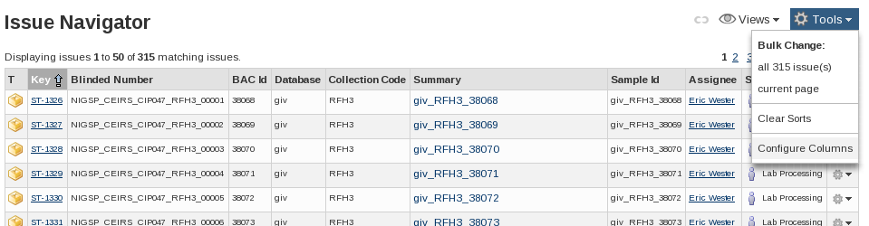
In the Issue Navigator:
Select the Tools drop-down menu, situated on the right above the list of issues.
Select Configure Columns at the bottom of the menu
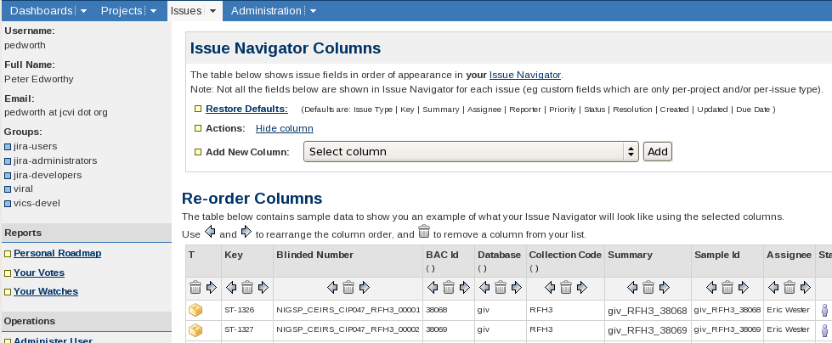
This screen allows columns to be added, removed and arranged.
Adding/re-adding fields is carried out one field at a time. Select the field to add from the 'Select Column' drop-down menu and then click 'Add'.
The menu contains all of the fields in JIRA and so can be quite long. The fields are in alphabetical order and so looking up the exact name of the field (as found on the Sample/Sub-Task's summary view) can save time.
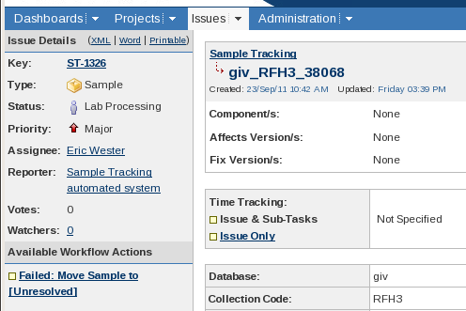
In the above screen shot the field names are 'Database' and 'Collection Code'
The rest of the operations are done using icons that are in the example table directly under the column titles. The icons are:
Swap the column with the column to its left or right
Remove the column. If a column is accidentally removed it can be re-added via the Add new
Column drop-down.

Missing Columns
Issue Type specific fields are not shown in the Issue Navigator unless that Issue Type has been explicitly selected. e.g. For the Collection Code to be visible 'Sample' must be among the Issue Types selected. Explicitly setting the issue type is needed even if the search only matches Issues of one Issue Type.

Advanced
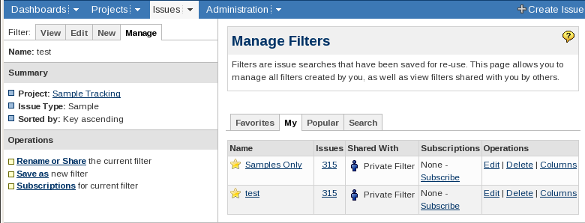
The above procedure sets and modifies a user's default column settings. If a search is saved in the Issue Navigator it can then have its own column layout associated.
The 'Columns' link under Operations opens the same 'Issue Navigator Columns' page.

